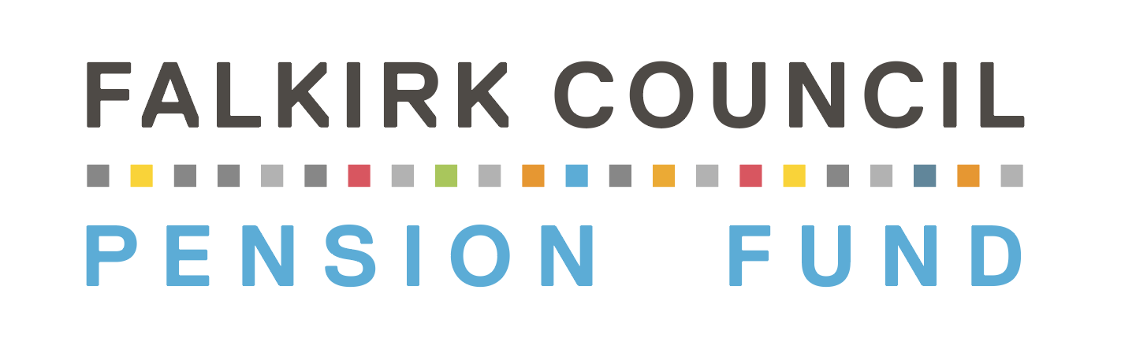
PRIVACY NOTICE

For the Members and Beneficiaries of the Falkirk Council Pension Fund
This notice summarises the key ways in which we deal with personal data and provides details of what information we collect from you, what we do with it, and who it might be shared with. Further information can be found on the Falkirk Council Pension Fund (the “Fund”) website at www.falkirkpensionfund.org.

Identity and contact details of the data controller and the data protection officer
Falkirk Council is the data controller in its capacity as data controller under the Local Government Pension Scheme. You can contact the data protection officer at:
Data Protection Officer
The Foundry
4 Central Boulevard
Central Park
Falkirk
FK5 4RU
data.protection@falkirk.gov.uk

Why do we collect this information?
The information is collected by the Council for the following purposes:
- To provide pensions, lump sums and death benefits to scheme members under the terms of the Local Government Pension Scheme

Legal Basis | Purpose
Consent
Performance of a Contract
Legal Obligation | 1
Vital Interests
Task to be carried out in the public interest | 1
Legitimate Interests

- To comply with the legal and public interest obligations, the Council needs to hold information about you (“personal data”).

This includes using your personal data to allow us to calculate and provide you and your beneficiaries with scheme benefits. We will also use your data for statistical and financial modelling purposes (for example, to work out how much money is needed to provide members’ benefits and how Fund assets should be invested).

In terms of Article 6(1)(c) of the General Data Protection Regulations, the processing of data is necessary for compliance with a legal obligation which at the time of writing, was Regulation 51 of the Local Government Pension Scheme (Scotland) Regulations 2014 (SI 2014/164).

Other legislation which may require the holding and processing of personal data includes the:

- Public Service Pensions Act 2013
- Public Service Pensions (Record Keeping and Miscellaneous Amendments) Regulations 2014
- Local Government Pension Scheme (Scotland) Regulations 2018
- Local Government (Discretionary Payments and Injury Benefits) (Scotland) Regulations 1998
- Occupational and Personal Pension Schemes (Disclosure of Information) Regulations 2013

What information do we collect about you?
The types of data we hold and process will typically include:
- Contact details, including name, address, telephone numbers and email address
- Identifying details, including date of birth and national insurance number
- Information about your benefits in the Fund, including length of service or membership and salary
- Other information in relation to your membership of the Fund or to enable the calculation or payment of benefits, for example bank account details
- Information about your family, dependents or personal circumstances, for example, marital status and information relevant to the distribution and allocation of benefits payable on death
- Information about a criminal conviction if this has resulted in you owing money to your employer or the Fund and the employer or Fund may be reimbursed from your benefits
- Information about your health, for example, to assess eligibility for benefits payable on ill health, or where your health is relevant to a claim for benefits following the death of a member of the Fund

Personal data relating to matters of health or children is classed as Sensitive Personal Data. Legislation requires that additional conditions are met in order for this type of data to be lawfully processed. Article 9(2)(b) of the General Data Protection Regulations permits processing of sensitive personal data where this is necessary for carrying out rights and obligations under employment, social security and social protection law.

Where do we collect information from?
We obtain some of this personal data directly from you. We also obtain personal data from your employer (e.g. salary information), Government agencies (e.g. HM Revenue & Customs, DWP through the Tell Us Once Service) and from other pension schemes. We may also collect data directly from other LGPS Funds or indirectly via the LGPS National Insurance Database: this is a database to which most LGPS Funds supply regular uploads of data and which is hosted by South Yorkshire Pensions Authority.

With whom might we share your information?
From time to time we will share your personal data with third parties, in order to comply with our obligations under law, and in connection with the provision of services that help us carry out our duties, rights and discretions in relation to the Fund. The main bodies with whom we will share data are:

 | Body | Reason for Sharing
1. | Fund Employers | To enable employers to maintain accurate records of fund membership and to provide information relevant to potential retirement scenarios.
2. | Fund Actuary and Government Actuary | To carry out financial and demographic analysis of the Fund in order to establish how much employers need to contribute to maintain Fund solvency.
3. | AVC providers - Prudential and Standard Life | To enable AVC providers to maintain accurate records and ensure AVCs are processed in accordance with member instructions.
4. | HM Revenue & Customs; | To comply with PAYE arrangements in relation to pension payments and to comply with tax legislation that relates to pension schemes.
5. | Printers | To enable the printing of pensioner payslips.
6. | The administrators of pension schemes in the UK and Overseas | To facilitate the transfer of pension rights between the Fund and other Schemes. In some cases, recipients of the data may be outside the UK. This may be where a member wishes to transfer pension rights abroad or wishes a retirement pension paid into a non UK bank account. If this occurs, we will make sure that appropriate safeguards are in place in accordance with applicable laws. If we do not consider that there are appropriate safeguards, we will require your written consent before transferring any information outside the UK. Please use the contact details on Page 4 if you want more information in connection with this.
7. | Strathclyde Pension Fund (SPF) | In connection with adjudication service which SPF provide in relation to member appeals.
8. | Scottish Public Pensions Agency | In connection with member appeals or complaints.
9 | Heywood | Software Providers of the Computerised Pensions Administration System – personal data is sent in a desensitised format.
10. | Independent Financial Advisers | To facilitate a transfer of pension rights for the member or assist a member with their financial planning.
11. | Police Scotland and other law enforcement or regulatory bodies | The Council has a duty to protect public funds and as such may check your information within the Council (e.g. with HR or Payroll) for verification purposes and/or for the prevention of fraud. We may share your information with other organisations where we are required to do so for the purposes of the prevention or detection of crime.
12. | External Auditor appointed by Audit Scotland | To comply with the statutory requirement to audit and report on the Fund’s annual accounts.
13. | Audit Scotland / Cabinet Office | To comply with the requirements of the National Fraud Initiative with a view to the prevention and detection of fraud.
14. | LGPS National Insurance database | To allow other Councils and other LGPS Funds to obtain membership information from a national database with a view to facilitating the administration of the Scheme and to avoid duplication of benefits.
15. | Secretary of State for Work and Pensions | To enable the Council to receive notifications of member deaths automatically using the Tell Us Once service and to simplify the process for deaths being notified by informants to public bodies.

Do I have to provide my personal data to you?
Yes. Your personal data is held to enable the Council to comply with the terms of the Local Government Pension Scheme and wider pensions legislation. Unless you have a contract for less than 3 months, the Scheme rules require you to be automatically enrolled into the Scheme in which case you and your employer are required to provide certain personal data to the Fund.

If you do not provide the relevant personal information this may affect the benefits payable to you under the Fund. In some cases it could mean that we are unable to put your pension into payment or have to stop your pension (if already in payment).

You should be aware that even if you were to opt out of the scheme, the Council would still be obliged to retain certain information as confirmation of your membership record in the Fund.

How long do we keep hold of your information?
We will keep your personal data for as long as is needed in order to administer the Fund in accordance with the law and to deal with any questions or complaints that we may receive about your entitlement.
In practice, this means that your personal data may be retained for as long as you (or any dependant beneficiary who receives benefits after your death) are entitled to benefits from the Fund and normally a period of 5 years after this.

Your personal data needs to be retained even if you have transferred your rights out of the Fund, opted out or had a refund of contributions. This is to evidence how your liabilities have been discharged.

Do you use any automated processes to make decisions about me?
No. We do not use any automated decision making processes in administering scheme benefits.

What are my rights in relation to the information held about me?
You have the following rights:
- To see any information held about you by making a subject access request.
- To withdraw consent at any time, where the legal basis for processing is consent.
- To data portability, where the legal basis for processing is (i) consent or (ii) performance of a contract.
- To request rectification or erasure of your information, where data protection legislation allows it.

Do I have a right to complain about the way information has been used?
If you have a concern about the way we are collecting or using your personal data, please let us know and we will try to resolve this. The Pensions Section address is;

Falkirk Council Pensions Section
PO Box 14882
Falkirk FK1 9BH

Tel: 01324-506329
Email: pensions@falkirk.gov.uk
If, having raised the matter, you are still concerned, you can contact the Information Commissioner:
Information Commissioner's Office – Scotland
Queen Elizabeth House
Sibbald Walk
Edinburgh
EH8 8FT

Tel: 0303 123 1115 (local rate)
Email: Scotland@ico.org.uk

Version Control
Version Number | Purpose/Change | Author | Date
0.1 | Initial Document | Pensions Manager | 21.5.2018
0.2 | Comments and revisals | Senior Solicitor | 24.05.2018
0.3 | Revisals | Pensions Manager | 01.02.2020
0.4 | Revisions | Pensions Manager | 21.03.2022
0.5 | Review | Data Protection Officer | 22.02.2022
0.6 | Revisions | Pensions Manager | 01.03.2025
0.7 | Revisions | Pensions Manager | 22.08.2025

