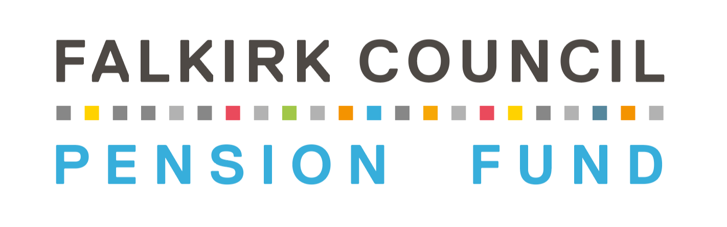

Pension Board

Constitution

31 March 2026

Version Control
Version | Date of Change | Last Committee/Board  Approval Date | Comment
1.0 | 12/06/2015 | 26/06/2015 | Constitution established and approved
1.1 | 01/06/2019 | 27/06/2019 | Constitution updated.
1.2 | 01/03/2026 | 31/03/2026 | Constitution reviewed and updated.

- Introduction

1.1 Falkirk Council is required by law to operate and maintain a pension fund under the terms of the Local Government Pension Scheme. The Council, which is the legally constituted decision-making body for pension fund business, has chosen to delegate this role to a Pensions Committee.

1.2 Under the terms of the Public Service Pensions Act 2013 and associated legislation, the Council is designated as a “Scheme Manager”.

1.3 Each Local Government Pension Scheme Manager in Scotland is required to establish a Pension Board separate from any Pensions Committee.

1.4 The Falkirk Council Pension Fund Pension Board is established under the provisions of the Local Government Pension Scheme (Governance) (Scotland) Regulations 2015.

1.5 The statutory role of the Pension Board is to assist the Scheme Manager in:

- Securing compliance with the rules relating to scheme governance and administration
- Securing compliance with requirements imposed by the Pensions Regulator
- Such other matters as may be specified in legislation

1.6 Full details of the Fund’s Governance arrangements can be found in its Governance Policy document which is located on the pension fund website at https://falkirkpensionfund.org/resources/ .

- Objectives

2.1 The Pension Board is the body responsible for assisting the Scheme Manager in relation to compliance with Pension Scheme Regulations and the requirements of the Pensions Regulator.

2.2 The Pension Board may consider any matters concerning pensions it deems relevant to Fund activities including:

- Reports produced for the Pensions Committee
- Reports from the Scheme Manager on any aspect of the Fund
- Monitoring investments and investment principles, strategy and guidance
- The Fund annual report and accounts
- External voting and engagement provisions
- Fund administrative performance
- Actuarial reports and valuations
- Funding policy
- Any other matters that the Pension Board deems appropriate

3. Membership

3.1 Membership of the Pension Board will consist of equal numbers of Member Representatives (see 3.2 below) and Employer Representatives (see 3.3 below), drawn from Clackmannanshire, Falkirk and Stirling Councils and the other scheduled and admission bodies in the Fund. Pension Board representatives must not participate in or act as members of the Pensions Committee.

3.2 There will be four Member Representatives who will be appointed by the following Trade Unions:

- GMB
- UNISON (2 delegates)
- UNITE

  - There will be four Employer Representatives appointed by participating employer organisations. The Local Authority Employer Representatives will normally be Elected Members serving as part of their respective Councils or, an employed Council Officer. The representatives will be drawn from the following organisations:

- Clackmannanshire Council / Stirling Council (where the seat on the Committee is taken by Stirling Council, Clackmannanshire Council would be represented on the Board and vice versa)
- Scottish Environment Protection Agency
- Scottish Childrens’ Reporter Administration
- Scheduled or Admission Body

3.4 Each Pension Board representative will serve for a period of four years and, subject to the agreement of their Trade Union, Council or employer, may be reappointed to serve further terms. Employer bodies and Trade Unions retain the right to withdraw representatives or identify replacements in line with their succession planning.

3.5 The Pension Board may invite advisers to attend meetings in a non-voting capacity.

3.6 A person may not be appointed to the Pension Board unless the scheme manager is satisfied that the person does not have a conflict of interest. In addition, a person may not continue as a member of the Pension Board if the scheme manager is no longer satisfied that the person does not have a conflict of interest. A conflict of interest is defined as a financial or other interest which is likely to prejudice a person’s exercise of functions as a member of the Pension Board. It does not include a financial or other interest arising merely by virtue of that person being a member of the scheme or any connected scheme for which the Board is established.

4. Role of the Chair and Chair Designate

  - The Member and Employer Representatives will each appoint a Chair for their side who will act as their Chair. The Chair of the Pension Board will rotate on an annual basis between the Member Representatives (Trade Unions) and Employer Representatives (Scheme employers). The person appointed by each side will act as the Chair of the Board when it is their turn to Chair the Board otherwise they will serve as the Chair Designate.

  - The person selected will serve as the Chair/Chair Designate for the remainder of their term of office on the Board unless they give notice to the Scheme Manager to demit office. The Chairs may serve a further term as Chair of the Board following reappointment to the Board by their Trade Union or employer providing they have been re-selected by their fellow Board members to do so.

  - At the end of each Scheme year the Chair of the Board will provide a statement for the Fund’s annual report and accounts that covers the work undertaken by the Board over the Scheme year to ensure the effective and efficient governance, and administration of the Fund.

  - The Chair and Chair Designate will meet with senior Fund officers:

- Twice a year to review the Fund’s risk register, and,
- If required, to support governance matters such as the completion of a governance survey issued by the Pensions Regulator

  - Where the Chair is unable to attend a Board meeting, they may appoint another member of the Board to act as the Chair for that meeting. If no deputy is appointed, then the Chair Designate will act as the Chair of the meeting.

- Meetings

  - The Pension Board will meet at least on a quarterly basis. While the statutory roles and functions of the Pensions Committee and Pension Board are separate, both bodies will meet at the same time to consider the same agenda. The Convener of the Pensions Committee will chair the joint meeting with the aim of fostering a positive and proactive partnership culture.

  - A majority of either the Member or Employer Representatives of the Board may requisition a special meeting of the Pension Board to discuss matters relating to regulation 9 of The Local Government Pension Scheme (Governance) (Scotland) Regulations 2015. Where a special meeting is held, both sides will meet at the same time and consider the same agenda. A minute will be produced and published unless paragraph 9 of Part 1 of Schedule 7A of the Local Government (Scotland) Act 1973 applies.

  - The quorum for any meeting of the Board is four Representatives.

  - Pension Board meetings will be administered by Falkirk Council and Board members will be expected to undertake their roles in accordance with the Code of Conduct and the principles of the Council’s Standing Orders relating to meetings.

  - All reasonable administration costs in respect of the running of the Pension Board shall be met by the Fund.

6. Dispute resolution

  - If the Pensions Committee and Pension Board cannot reach joint agreement in any matter the process for resolving any differences between the two bodies will be as outlined below. Whilst this process is undertaken the decision of the Pensions Committee stands.

  - In the first instance, if at least half of the Board members agree, then the Pension Board can refer a decision of the Pensions Committee back to the Committee for further consideration if any of the following grounds are met:

- That there is evidence or data on which the Pension Committee relied when making their decision which is considered to be unreliable or there is new evidence or data which the Pension Committee did not access or was not aware of at the point of making the decision which is considered material to the decision taken
- That the decision of the Pensions Committee is arguably beyond the powers of the Local Government Pension Scheme regulations or otherwise unlawful
- That the decision of the Pensions Committee is contrary to a relevant Code of Practice published by the Pensions Regulator
- That the decision is not in the interest of the continued financial viability of the Scheme or is against the principles of proper and responsible administration of the Scheme

6.3 If there is no agreement after the matter has been referred back to the Pensions Committee, then the difference in view between the Pension Board and the Pensions Committee will be published in the form of a joint secretarial report on the Pension Fund website and included in the Fund’s annual report.

6.4 The national Scheme Advisory Board may also consider and take a view on the matter and, if considered appropriate, provide advice to the Scheme Manager or the Pension Board in relation to the matter.

7. Training

7.1 All members of the Pension Board must undertake a training programme in accordance with the Fund’s Training Policy and the best practice training requirements of the Pensions Committee.

7.2 The Scheme Manager, under delegation to Fund Officers, will keep an updated list of the documents with which it considers Pension Board members need to understand, to effectively carry out their role and make sure that both the list and the documents are accessible.

8. Access to Information

8.1 The Scheme Manager and the Pensions Board will together ensure that information about the activities of the Board is published on the Pension Fund website, https://falkirkpensionfund.org/resources/, including:

- The constitution of the Pension Board
- The name and organisation of Board members, and
- Any specific roles and responsibilities of individual Pension Board members

8.2 The minutes of the Pension Board (whether this is a minute of a joint meeting with the Pensions Committee or the minute of a separate Board meeting) will be published on the Falkirk Council website www.falkirk.gov.uk.

8.3 The Pension Board may undertake such communications and stakeholder engagement as it deems appropriate to perform its functions.

9. Effect of Constitution

9.1 The Pensions Committee, as scheme manager under delegation by Falkirk Council, agreed to the terms set out in this constitution at its meeting on 31 March 2026.

Falkirk Council Pension Fund Scheme Manager
31 March 2026

